

**NATIONAL UNIVERSITY OF SCIENCES AND TECHNOLOGY**

School of Electronic Engineering and Computer Sciences

**Formal Methods**

**Assignment#3**

**SUBMITTED TO:**

Dr. Sohail Iqbal

**SUBMITTED BY:**

|  |  |
| --- | --- |
| **Name** | **Reg Number** |
| Afzaal Ahmad | 124245 |

**GitHub Link:** [**Assignment 3**](https://github.com/afzaalahmad969/fm_assignment3)

**Q1:**

**(i)**

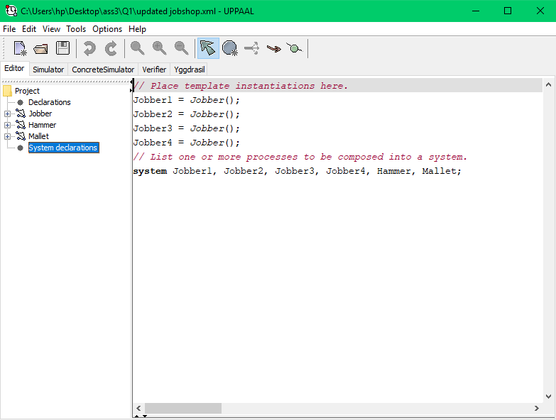

**(ii)**

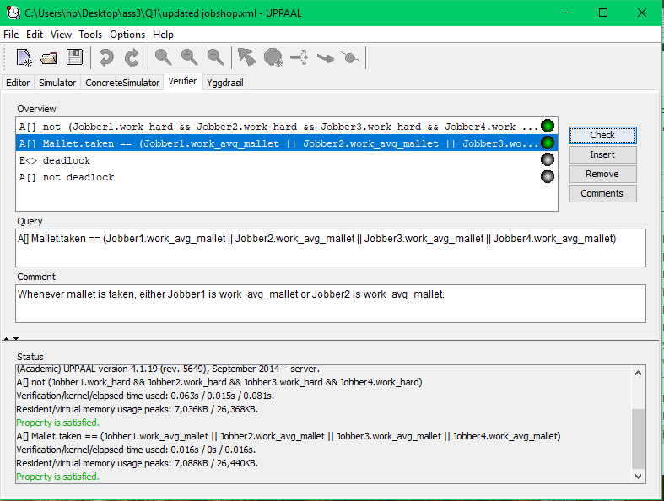

**Q2:**

**Model:**

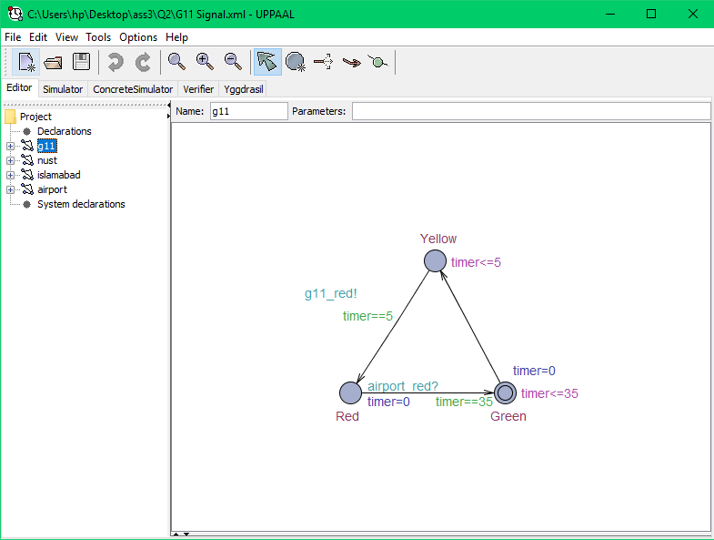

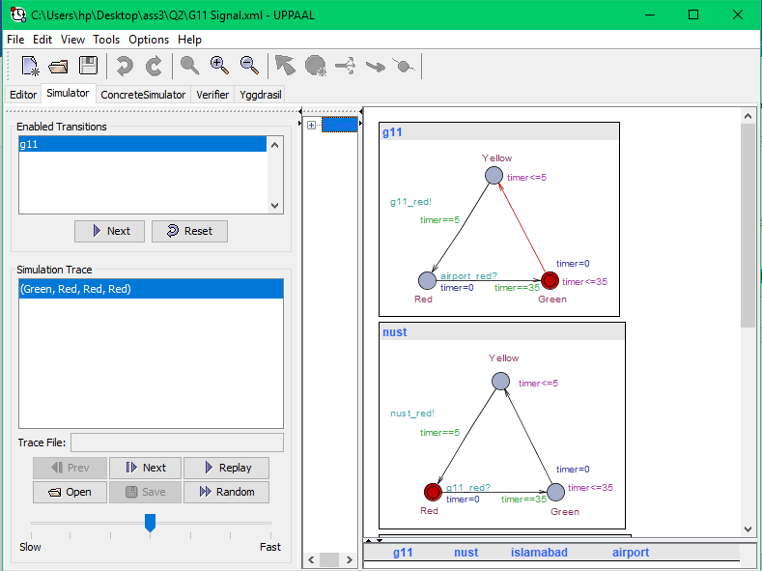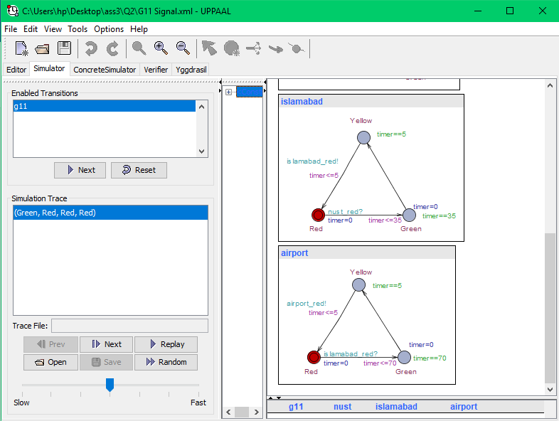

**Mutex Property:**

A[] not (g11.Green && nust.Green && airport.Green && islamabad.Green)

**Mutex Property Verification:**

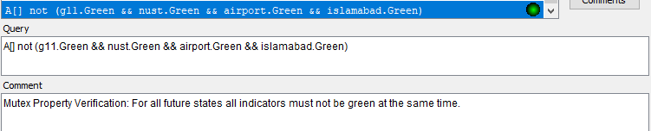

**Bounded Liveness Properties:**

E<> g11.Green

E<> airport.Green

E<> nust.Green

E<> islamabad.Green

**Bounded Liveness Properties Verification:**

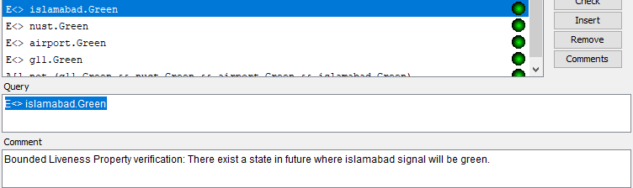

**Bounded Liveness Properties:**

A[] not (g11.Red && nust.Red && airport.Red && islamabad.Red)

**Bounded Liveness Properties Verification:**

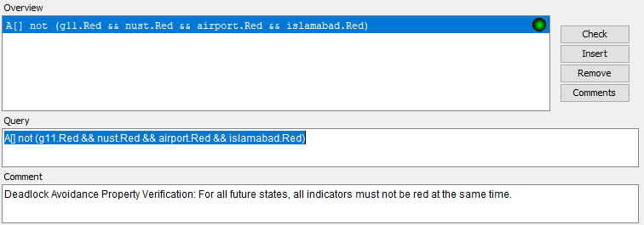

**Facebook Sharing Screenshots:**

